**Matoshri College of Engineering and Research Center**

**Eklahare ,Nashik**



**PROJECT BASED LEARNING REPORT**

**ON**

**“SMART IRRIGATION SYSTEM”**

***Submitted by***

Om Rajesh More (F190580364)

Sarthak Vijay More (F190580367)

Shashikant Balasaheb Khade (F190580277)

**DEPARTMENT OF ENGINEERING SCIENCES**

**YEAR 2022-2023**

**Matoshri College of Engineering and Research Center**

**Eklahare ,NashiK**



**CERTIFICATE**

This is to certify that the project work entitled **“ Smart Irrigation System”,** has been successfully completed during the academic year of 2022-2023 by the following students:

Om Rajesh More (F190580364)

Sarthak Vijay More (F190580367)

Shashikant Balasaheb Khade (F190580277)

This project conforms to the standards laid down by SPPU and has been completed in FE degree in AI&DS Engineering, SPPU.

**Dr. Dnyanrshwar.D.Ahire Dr. G.K.Kharate**

**Project Guide H.O.D. Principal**

**ACKNOWLEDGMENT**

We would like to thank our Head of Department, Prof. Dr. D. D.Ahire sir for all the guidance and help provided us for this project. We express our humble gratitude for being with us and for all the help needed.

We would extend deep gratitude towards Mr KR Sonawane for guidance and selection of our project. Madam has given us very important guide lines that helped us for strengthening the objective of our project.

Finally we would like to express our sincere gratitude towards Mrs. A.V.Tidke for helping us to complete our project.

**ABSTRACT**

The project presents the use of correct soil moisture sensors which helps to ease out the pain to monitor and keep records about the changes in soil moisture. Using the Arduino Mega micro controller with Light-Depended Resistor sensor, moisture sensor and temperature sensor, temperature are measured and analyzed. The soil for a certain duration, provides information related to the moisture status of the soil. The Arduino Mega will collect and process the data received from the Sensors. When a threshold moisture level of the soil is reached, the water will supply accordingly. This is essential because water must be provided to the plant at a particular time for a good yield. This project is highly use for farmers, Nursery professionals by eradicating traditional or manual method of irrigation system.

**CONTENTS**

|  |  |  |
| --- | --- | --- |
| Chapter No. | Title | Page No. |
| 1. | Introduction | 6 |
| 2 | Literature survey | 12 |
| 3 | Conclusion | 15 |
| 4 | Visual Figure of system | 18 |
| 5 | Block Diagram Of System | 19 |
| 6 | Flowchart of the Project | 20 |
|  |  |  |

**Chapter 1: Introduction**

**F**rom massive agribusiness players like Cargill to small organic farmers, growers all over the world are using the Internet of Things to reduce their consumption of water and fertilizers, cut waste and improve the quality or yield of their products. Examples range from tracking microclimates across cropland, to closely monitoring temperature changes and humidity levels as perishable goods move from field to warehouse to store in order to extend their shelf life and eliminate waste. California's recent historic drought forced many growers to search for ways of using less water. Tech providers are helping them with tools such as drone imagery and soil sensors, which measure real-time conditions. According to The Nature Conservancy, such precision agriculture can enable farmers to cut water and fertilizer use by up to 40 percent, without reducing yields. By improving the irrigation efficiency in agricultural sector, this industry become more competitive and sustainable. Also, in dry areas, where there is no sufficient rainfall, proper irrigation is not possible. Hence by using this irrigation system by monitoring the moisture content of soil are can meet the water requirements necessary for the field. To save effort of farmers, the important considerations are water and time. In present condition, they need to wait until field is fully watered. This restricts them to do other activities. This idea is not only meant for farmers but also for watering the plants. In our present era, the farmers are irrigating their crops at regular interval of time. The techniques they use will consume more water by creating water logging and results in water wastage. This system that we designed will completely eliminate the stress of manual Labour. Two types of soils have been tested and it will only work when the soil condition is dry Agriculture is the backbone of all developed countries. It uses 85% of available fresh water resources worldwide and this percentage continues to be dominant in water consumption because of population growth and increased food demand. Due to this efficient water management is the major concern in many cropping systems in arid and semi-arid areas. Arduino based plant communicator helps the farmer by checking the moisture of the soil and if the moisture is below the level then automatic water is irrigated. Over irrigation occurs because of poor distribution or management of waste water, chemical which lead to water pollution. Under irrigation leads to increase soil salinity with consequent buildup of toxic salts on the soil surface in areas with high evaporation.

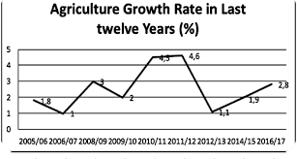

***Figure 1: Agriculture Growth rate in last 12 year (Chaudhary, 2018)***

To overcome these problems and to reduce the man power plant communicator system has been used (S. Darshna, 2015). Figure 1: Agriculture Growth rate in last 12 year (Chaudhary, 2018) The above chart shows the growth of agriculture in Nepal with the growing rate traditional irrigation has lots of limitation because they are operated manually. However, the modern and automated tools like this simplify the everyday task which makes end product cost effective and high production.

**1.1 Current Scenario**

Plant Communicator in content of the local market is a new concept. It has not yet been introduced here. However, considering the international market, Plant Communicator is very popular. There are many companies such as Kisan Group of Companies, GreenGold Irrigation Private Limited, Balson Polyplast Private Limited all dedicated towards making plant communicator targeting various trades such as fertilizers, organic fertilizers, sprinkler irrigation system and more plant communicator with different feature such as monitoring moisture, temperature and light and irrigating the plant if the moisture is below the level (Patel, 2015).

**1.2 Problem Domain**

Internet of Things (IoT) in the context of Nepal is not quite affordable or available. Though 0there remains an eagerness for technology, this is largely due to the ignorance of the emergence of those very technologies, lack in adapting to the pace of change and lack of adequate budget with general population. This project targets the agriculture sector with focus on making a cheaper and utility-based variant of the plant communicator in alternative to those already existing in the international market.

**1.3 Aim & Objective**

**1.3.1 Aim**

The main aim of this project is to create plant communicator device based on Arduino which help us to monitor moisture, temperature, light and irrigate if the moisture level is below.

**1.3.2 Objective**

• Create a plant communicator device based on Arduino, Moisture, Temperature and light sensor

• Use Arduino IDE for coding in Arduino device and various dependencies.

• Proper research for Arduino device and its circuit.

• Proper circuit design for the project.

• Proper testing and debugging of the device configuration.

• Create proper prototype of Plant Communicator.

• Conducting a survey regarding the project.

• Provide the proper value of Moisture, Temperature and Light.

• Research on various similar system.

**1.4 Structure of Report**

Here in this section it provides the information about the overall format of the report. Various heading, sub-heading is there like Introduction, Background, Development, Testing and Analysis and Conclusion. Below will be described accordingly,

**1.4.1 Introduction**

The first section of the report will be the introduction. This will contain several subsections, as outlined. Various sub-headings like project description, current scenarios, problem statement, aim and objectives are discussed. This is the main starting part of the report so this will provide all the description about the project in every aspect.

**1.4.2 Background**

There should be some background information on the topic are. There will be information regarding client, understanding the solutions, review of technical aspect and similar system and overall comparisons of the project. Various sub-heading will define various subjects. Here various feature of the project will be defined and understand the solution of the client. After that there will be review of similar system and project where system provide information about project which are in market but project gives which were limited only in research paper. And at last comparison is done between others system.

**1.4.3 Development**

Here should be some of the information about the development part. During the development of the prototype which methodologies where used and which was suitable will be described. During the time how, various stages were passed must be described in this section. And one main thing is that the how the code was developed has to be placed here in this section.

**1.4.4 Testing and Analysis**

Testing and Analysis is the section where the final prototype is tested in various type. One is system testing where overall system is tested and another one is unit testing which is done with single module. But in this report overall testing is done where everyone can get brief description about system and unit testing. And at last overall analysis is done to final prototype is done.

**1.4.5 Conclusion**

In this Conclusion section, whole report is sum up. At this part various issues like ethical, social and legal issues will be discussed as well as advantages and limitations also will be discussed.

**2.1 Survey**

As in this section the various survey that has been taken for the base decisions on objective information and to compare the results. There we several questions which provides a snapshot of the attitudes and behavior’s including thoughts, opinions and comments about survey populations. And the feedbacks are much valuable to baseline to measure and establish a benchmark from which to compare results over time. The various survey questions and the answer are on the Appendix section.

**2.2 Project Elaboration**

The first prototype of the plant communicator would be able to deliver the moisture, temperature and light of the soil. Farmer will be able to get the information about soil. Overall after completion of the prototype additional feature as self-irrigation is added. Here self-irrigation works when the sensed value goes beyond the threshold values set in the program, the pump will be automatically switched ON/OFF by the relay circuit and it is connected to the driver circuit which helps to switch the voltage. By using this system, the farmer, agriculturist and nursery will be highly benefited because this system is cost effective, easy to operate. Traditional or manual way of irrigation system will be time consuming and more uses of water but this system will help user by self-irrigating, which help to save time and save a lot of water.

**2.2.1 Design Requirement**

Connectivity Internet connectivity was required to achieve remote access to the controller from around the globe. It is intended that the end user will be able to control their irrigation system via tablets, smartphones, and computers. Texas Instrument’s Beagle Bone Black (BBB) board provides Ethernet or USB/Adapter Internet connectivity options.

**Manual Operation**

Manual operation of the controller was determined to be required. This would allow control over the system without the need of a smart device and Internet connectivity. Irrigation systems often require maintenance provided by system experts. Manual operation gives these experts access to the system while minimizing security risks, as the use of remote control to the system would require network access. Manual operation of our controller would include one button to cycle through the zones and sixteen LEDs to indicate zone operation. The button can be programmed to do whatever the software designers need.

**Installation**

The only installation requirement associated with our design was that it be a replacement of existing common controllers. Thus, being powered by a 24 V (AC) plug in transformer and wired to corresponding zones. However, for the device to be used as a “Smart” controller, it was required that it be connected to the Internet. This is achieved in two ways: the first is Ethernet Connection and the second is USB Wi-Fi Adapter (range limited). Assuming the user has Wi-Fi Internet and the controller is within a suitable range, the controller is simply a replacement of most existing sprinkler controllers. If the controller is out of Wi-Fi range the Ethernet connection must be used.

**2.4 Necessity of the Project**

Day by day the population is increased which gives negative impact in water resources. As below figure illustrates the per capita water use and per capita water resources. From the below graph it is clear that the years passes per capita water use increases and per capita water resources falls. So, it’s our duty to save the planet from water depletion and conserve a single drop of water that being wasted unnecessary during the irrigation. While doing this, water wastage will be more by water logging. So “Plant Communicator” system is necessary to conserve water since the pump gets turn on and off automatically according the condition of the program. One of the main objectives of this system is to remove human is to remove control from filed for watering the plant and it is time saving (C. M. Devika Karthika Bose, 2017).

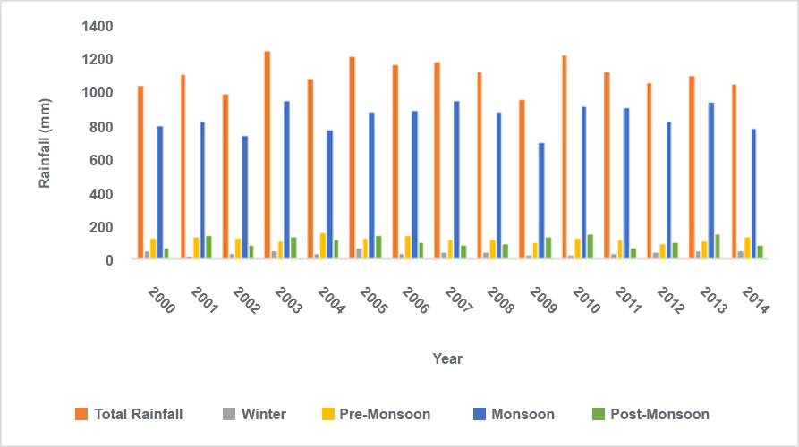

***Figure 3: Total water uses and per capita water resource***

To talk about Internet of Things (IoT) is to be used in the field of agriculture this will help in crop production. Internet of Things (IoT) won’t fix the problems related to irrigation but if this can help in boosting crop production in one way or another way or another way and can decrease human Labour to some extent. Involvement of technology in this filed might make people attracted towards farming and might also remove their concept for it being as low standard job.

**Chapter 5: Conclusion**

Irrigation is the vital component for economic in any developing countries like Nepal. Over the years, professionals involved in irrigation implemented manual method of irrigation. The manual method has lots of drawbacks and is quite unreliable for irrigation of big areas. Irrigation has direct impact on cost and production of final product. This system aims to eradicate the tractional manual method of irrigation which needs to be improved over the time. Moreover, the problem domain explains the requirement of plant communicator and irrigation systems that can be used by farmers and flower Nursery professionals. This testing phases of the project justifies that this project can be used in a real time farming environment. Also, the project was developed after studying the market requirement which makes it extremely suitable in the context of present scenarios. The post survey result provides that the system is useful in real time scenario and end users are interested in using this system.

**5.1 Ethical Issues**

With the development of wireless technology physical objectives can be connected together on the internet. There are many new risks and vulnerabilities risen from transferring data between different electronic devices, many of them are belong to ethics issues. Massive amount of data provided by the various sensor are beyond the ethics of the users. If the value of sensor shows the wrong value then it will beyond the ethics.

**5.2 Legal Issues**

This project was created with an intended to be used for good work. Even if this project is good this system can be used for various illegal activities like weed farming, Cocaine plant farming, etc. with little modification in the code. Using this system for such illegal activities violates the law of Nepal Government and consequences of such activities are punished according to law.

**5.3 Advantages of the Project**

This project targets the farmer, cultivator and nursery which help them a lot. “Plant Communicator” offers a variety of advantages over traditional irrigation system. As to talk about the advantages of the project, firstly there is soil moisture sensor which allows for water use only when and where needed which help in conservation of water. Generally speaking, traditional watering method can waste as much as 50% of the water used due to inefficiencies in irrigation, evaporations and overheating. After that the data are real-time data where farmer can visualize water level and moisture of spores in real time. “Plant Communicator” system uses sensor for real time data to inform watering routines and modify watering schedules to improve efficiencies. Automating process in irrigation can reduce resources consumption, human error and overall costs which help the farmer to lower the operation costs. This will result in energy conservation and it is one of the great solutions for water depletion and water scarcity. The machine- to- machine interaction provides better efficiency; hence accurate results can be obtained fast. This result in saving valuable time. Instead of repeating the same task every day, it enables people to do other creative jobs. This project helps the farmer to increase the productivity by providing the required amount of water. At last this system help to reduce soil erosion and nutrient leaching. This project is feasible and cost-effective for optimizing water resources for agricultural production. This project allows cultivation in places with water scarcity thereby improving sustainability. It proves that the wastage of water can be reduced. I conclude that this system is very easy to implement. Here user should visualize his soil’s moisture content from time to time and check whether the water level is sufficient or not. “Plant Communicator” displays the values of the water level in Arduino IDE monitor system for the user so that user can operate them anytime.

**5.4 Limitation of the Project**

As to talk about the limitations of the project, this system work under the condition of light. there will be two condition if the light is above the required value moisture performs its task, but if the light is under the required system then the moisture does not perform its task. This system targets small projects like mushroom farm and indoor farm so, if the farmers try to implement in big farm some error may occurs. This system does not receive local weather which determine when a landscape should water.

**5.5 Further Work**

The performance of the system can be further improved in term of the operating speed, memory capacity and instruction cycle period of the microcontroller by using another high-end controller. The number of channels can be increased to interface a greater number of sensors which is possible by using advanced versions of controllers. The system can be modified with the use of a data logger and a graphical LCD panel or using ThingsSpeak API to show the measured sensor data over a period of time. this device can be made to perform better by providing the power supply with the help of renewable sources. Time bound administration of fertilizer, insecticides and pesticides can be introduced. A water meter can be installed to estimate the amount of water used for irrigation and thus giving a cost estimation and a solenoid valve can be used for varying then volume of water flow.

 **Visual Figure Of Smart Irrigation System**

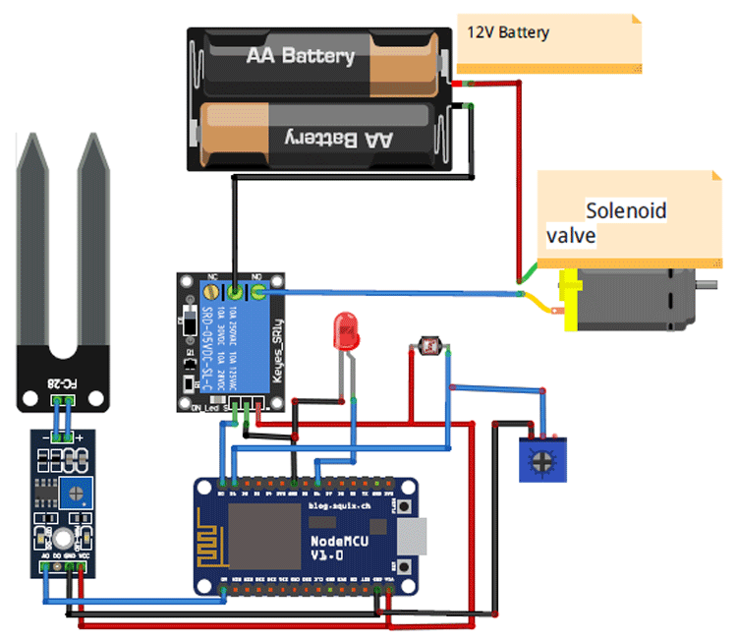

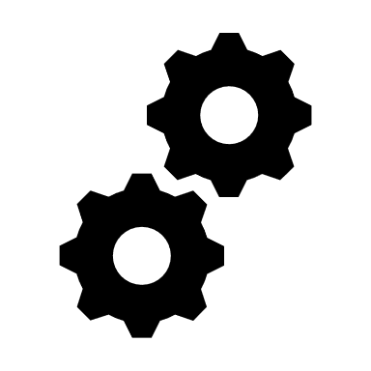 **Block Diagram Of Smart Irrigation System**

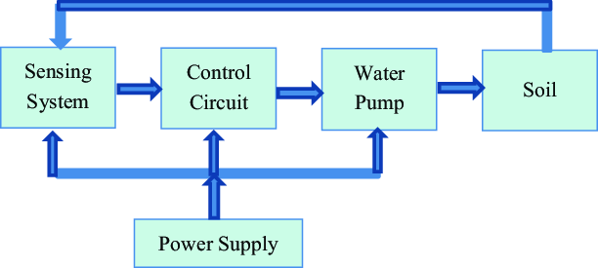

**Flowchart Of the System**

